Title: Large-scale functional organization of lateral frontal cortex

Alejandro de la Vega*1,2,3, Marie T. Banich1,2, Tor D. Wager1,2 and Tal Yarkoni3

1 Department of Psychology and Neuroscience, University of Colorado Boulder, 80309 2 Institute of Cognitive Science, University of Colorado Boulder, 80309 3 Department of Psychology, University of Texas at Austin, 78712

Contact Information: Alejandro de la Vega, Department of Psychology, University of Texas at Austin, 78712, 650-315-9536, email: delavega@colorado.edu

Conflicts of Interest: The authors declare no competing financial interests.

Acknowledgments: R01MH096906 National Institutes of Health.

Abstract (250 words)

The human lateral frontal cortex (LFC) is hypothesized to play an important role in a wide range of psychological processes, including the flexible adaptation of behavior in support of task-related goals. However, no consensus mapping between LFC anatomy and discrete psychological states has emerged from extensive fMRI study of this area. In the present study, we used a data-driven approach to generate a comprehensive functional-anatomical mapping of LFC from the largest available meta-analytic database of 11,406 neuroimaging studies. First, we identified putatively separable LFC regions by exploiting differences in whole-brain co-activation to group voxels into spatially distinct clusters, revealing 14 LFC sub-regions hierarchically organized into three whole-brain networks: fronto-parietal, default and sensori-motor. Next, we used multivariate classification to identify the psychological states most strongly predictive of brain activity for each cluster, resulting in dissociable psychological profiles for each sub-region. We observed large functional differences between regions in different networks, supporting the view that large-scale brain networks support categorically different modes of processing. Within each network, however, we observed relatively low functional-anatomical specificity, suggesting the modular organization of discrete psychological processes within LFC, such as ‘working memory’, has been vastly overestimated. Instead, our results are consistent with the emerging view that individual regions within networks work in a distributed fashion to enable flexible, adaptive behavior.

Flexible behavior is the hallmark of human and nonhuman primates. Such flexible behavior enables the navigation of complex, rapidly changing environments, the pursuit of goals in the face of various obstacles, planning for hypothetical future events and the communication of complex ideas with others using language. Decades of research have suggested lateral frontal cortex (LFC) supports a range of discrete psychological functions critical for supporting high-level behavior (Goldman & Rakic, 1996; Miller at al. 2011). Although extensive work has identified putatively separable psychological processes critical for flexible behavior– such as ‘working memory’, ‘inhibition’ and ‘conflict’– the precise organization of these processes within discrete lateral frontal anatomy remains actively debated.

Much progress has been made in understanding the LFC’s functional organization by identifying putatively separable LFC sub-regions on the basis of properties that constrain information processing. For instance, discrete regions have been proposed based on differences in anatomical microstructural properties (e.g. cytoarchitecture)*1* and anatomical (??) and resting-state functional connectivity (??). Although these studies have helped carefully characterize important functional properties of LFC, it is unclear to what extent the boundaries derived from such methods correspond to the organization of brain activity observed during distinct psychological states *5-7*.

One approach used to map the functional correlates of distinct behavioral phenotypes is the quantitative meta-analysis of functional MRI (fMRI) studies. Such meta-analyses help overcome the low power observed in most individual fMRI studies and produce more precise spatial maps of psychological states that activate LFC, such as working-memory *8,9*, switching *10*, language *11,12*, mentalizing *13* and self-referential processing *14*. However, due to the effort required to compile meta-analyses and because most researchers are interested in a particular psychological domain, most meta-analyses are typically focused on a particular sub-region of LFC or a subset of domain-specific set of psychological processes.

The narrow scope of most existing meta-analyses necessarily limits the extent of their impact for two reasons. First, there is an emerging view that individual regions fire in concert with dynamic whole-brain networks, such as the fronto-parietal network, to support complex behavior (??). Thus, it is critical to interpret the function of each region in a broader context in order to understand their role within large-scale networks and to better identify subtle differences between similar regions in the same network. Second, due to a limitation known as the reverse inference problem *15*, without contrasting studies that activate a region of interest to a diverse range of studies that do not, it is difficult to determine if a psychological function preferentially recruits a region, or if this association is due to domain-general functions underlying a wide-ranging set of psychological states. This limitation is particularly acute in regions of the brain active frequently across a broad range of tasks. Hence, by the very nature of the LFC being involved in a broad range tasks due to its critical role in flexible behavior, subregions of this area are particularly difficult to associate with specific mental operations *16,17*.

Here we address these issues by creating a comprehensive mapping between psychological states and LFC using Neurosynth *17*, a framework for large-scale fMRI meta-analysis composed of nearly 11,500 studies. First, we used a data-driven method that exploits the observation that functionally related regions co-activate across studies *18-20* to cluster individual voxels into putatively separable sub-regions (Figure 1A). We applied clustering at two spatial scales, identifying three distinct whole brain networks in LFC composed of several smaller sub-regions with dissociable patterns of whole-brain co-activation (Figure 1B). We then characterized the functional profile of each resulting region using multivariate classification, contrasting studies that activated each region to those that did not, and thus revealing dissociable psychological profiles for each LFC sub-region (Figure 1C). Collectively, we provide a comprehensive and unbiased functional-anatomical mapping of LFC using the largest meta-analytic database presently available.

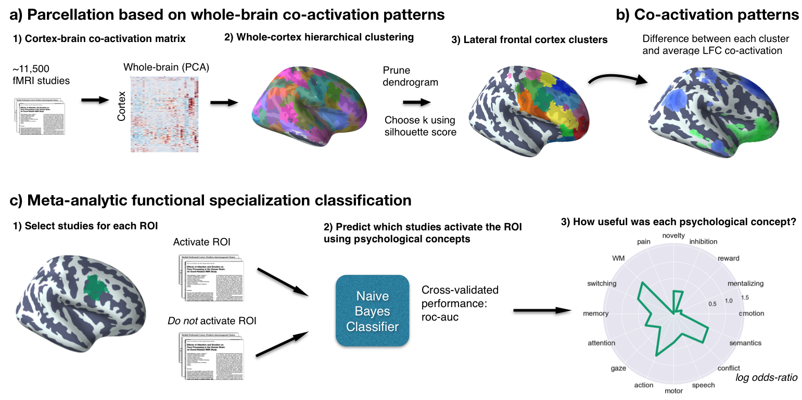**Figure 1. Methods overview.** a) We calculated co-activation across studies between every cortical voxel and the rest of the brain. We then applied Ward hierarchical clustering to obtain whole-brain clustering results. We chose two spatial scales to focus on using the silhouette method and selected clusters in LFC from the whole-brain clustering solutions. b) We contrasted the whole-brain co-activation of each cluster to LFC at large, identifying voxels across the brain that showed differential co-activation. c) We generated functional preference profiles for each cluster by determining which psychological topics best predicted their activation across studies in the database.

**Results**

## **Hierarchical clustering of lateral frontal cortex.** We identified spatially dissociable regions on the basis of shared co-activation profiles with the rest of the brain *18,20,23*, an approach that exploits the likelihood of a voxel co-activating with another voxel across studies in the meta-analytic database. In order to identify whole-brain networks spanning beyond LFC, we applied hierarchical clustering to cortex across the brain and selected clusters with a significant number of voxels within an *apriori* LFC mask for further analysis.

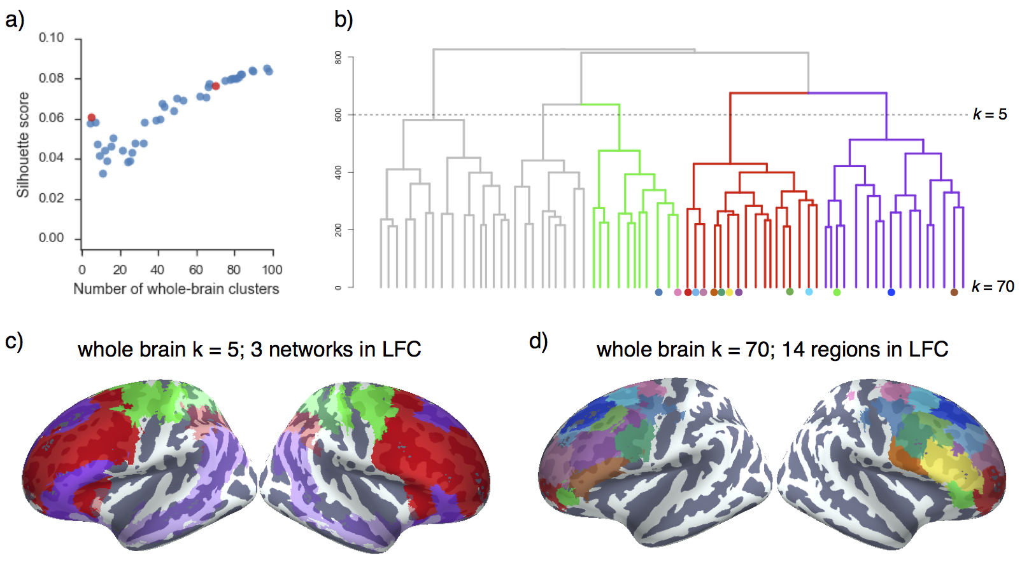  
**Figure 2. Whole-cortex co-activation based hierarchical clustering reveals 4 networks in lateral cluster that fractionate into constituent sub-regions.** a) Silhouette score, a measure of intra-cluster cohesion, was used to select two spatial scales: 5 and 70 whole-brain clusters b) Whole brain hierarchical clustering dendrogram. Color-coded branches correspond to three of five whole-brain networks in LFC and color-coded nodes correspond to 14 LFC regions from 70 whole-brain clusters. c) Flat clusters at *k =* 5 revealed three clusters in LFC resembling large-scale brain networks: task-positive control (red), default (purple) and somatosensory-motor (green) d) Clustering at *k* = 70 whole-brain clusters, we identified 14 clusters with a majority of their voxels in LFC.

We mapped structure to function across various spatial scales by extracting 4– to 100– flat whole-brain clusters and evaluating their quality using the average silhouette value, a measure of intra-cluster cohesion (Figure 2A). Since silhouette scores did not suggest a preference for a single dominant solution, we focused on two well-spaced solutions at two levels of granularity, avoiding low scoring solutions from 7-38 clusters. At the low end, we chose 5 clusters as this scale had the greatest silhouette score of coarse network-level solutions; at a finer scale, we focused on the 70- cluster solution, as this granularity was the first to result in a set of largely spatially contiguous LFC clusters (Figure 2B). Given the arguably intractable nature of choosing the ‘correct’ number of clusters (Varoquaux and Thirion, 2014; Eickhoff et al., 2015; Poldrack and Yarkoni, 2016), we do not argue that the two levels we selected are in any way privileged; rather, these two spatial scales simply provided two distinct vantage points into the hierarchical organization of LFC.

In the five-cluster whole-cortex solution, we identified three brain-wide clusters with a presence in LFC (Figure 2C). These clusters showed moderate correspondence to previously described large-scale networks: *22,24* fronto-parietal, default, and sensori-motor. Although these clusters were not isomorphic with resting-state networks– these results are consistent with the view that large-scale brain networks supersede anatomically boundaries, such as LFC, as functional-organizational units.

The fronto-parietal network was the largest network in LFC, spanning about half of its volume, and was primarily situated in prefrontal cortex. This network resembled previous descriptions of the fronto-parietal network (Yeo et al., 2021; dice coefficient (d) = 0.56), while additionally spanning medial-frontal and anterior insular aspects of the “ventral attention network” or the “cingulo-opercular network” (d = 0.21) (Power et al., XXX). A second cluster, also in prefrontal cortex, closely matched previous extensive descriptions of the default network (d = 0.62) *25*. Finally, a third cluster, located in posterior LFC, moderately overlapped with Yeo’s somatosensory-motor network (dice coefficient (d) = 0.36). This network encompassed dorsal primary motor and somatosensory cortices, premotor cortex, and the supplementary motor area (SMA), while also extending slightly more posterior into lateral aspects of Yeo’s dorsal attention network (d=0.31).

Within these three large-scale networks, we identified 14 finer-grained regions with a majority of voxels (75%+) within our LFC mask (Figure 2D). To provide direct insight into the functions of the 14 LFC fine-grained clusters we identified, we applied two approaches. First, we determined which voxels across the brain differentially co-activated with each, revealing distinct patterns of co-activation for each cluster. Second, we used semantic data from Neurosynth to determine which psychological states predict the activation of each cluster, resulting in a dissociable meta-analytic functional profile for each sub-region. Next, we step through these results separately for each network.

**Fronto-parietal network**

The majority of lateral frontal cortex belonged to the frontal extent of the fronto-parietal network, which further spanned portions of lateral parietal cortex (LPC), anterior insula (AI), pre-SMA, mid-cingulate cortex (MCC), and the precuneus. Within LFC, we identified 10 finer-grained sub-regions of the fronto-parietal network. For illustrative purposes, we organized these clusters into three groups based on their grouping at a coarser granularity (*k = 24):* caudal, mid and rostral regions. To preview later analyses, across these three grouping, although all clusters primary associated with executive functions, we observed subtle variations in functional profiles between the three groupings.

In caudal LPFC, we identified two adjacent bilateral clusters (Figure 3a). The most posterior of the two (‘6/8’) was located anterior to the premotor cortex and extended from lateral superior frontal gyrus to the intermediate frontal sulcus of middle frontal gyrus. This cluster overlapped with functional descriptions of the frontal eye fields (FEF)– a region important for volitional eye saccades *29*. Immediately anterior, we identified a cluster (‘9/46c’) spanning caudal area 9/46 from the intermediate frontal sulcus into caudal portions of 9/46v. Notably, although cluster ‘9/46c’ arguably extends into well into “mid” LPFC, this cluster did not group with other mid-LPFC clusters until much coarser granularities, suggesting these clusters may exhibit a distinct functional signature despite their spatial proximity.

Anterior and ventral to caudal LPFC, we identified four clusters spanning common definitions ‘mid’ lateral prefrontal cortex (Figure 3b). The organization of clusters in this region, however, varied by hemisphere. Most dorsally, we identified a mostly left-lateralized cluster (‘9/46v’), extending from the intermediate frontal sulcus into the fundus of the inferior frontal sulcus. Next, we identified a cluster, which we refer to as right IFG (‘IFG [R]’), spanning the majority of area BA45 in the right hemisphere. Notably, only right IFG was part of the fronto-parietal network, consistent with the observation that this region is consistently observed during goal-directed cognition. Posterior to these two clusters, we identified a bilateral cluster consistent with the inferior frontal junction (‘IFJ’) (e.g. MNI coordinates 48, 4, 33; *30,31*) located in the fundus of caudal inferior frontal sulcus, extending into precentral, inferior frontal and middle frontal gyri. Finally, ventral to this cluster, but only in the right hemisphere, we identified a fourth cluster (‘44 [R]’) located in posterior IFG, spanning BA44 and abutting BA6.

In ‘rostral’ LPFC, we identified three bilateral clusters spanning BA10 (Figure 3c). These three clusters were organized along a ventral-dorsal axis, consistent with a prior DTI parcellation *{Orr:2015fw}*, and were exclusively in lateral frontal cortex, consistent cytoarchitechtonic evidence of a lateral-medial distinction of the frontal pole *32*. The most dorsal cluster (‘9/46dr’) extended into rostral portions of BA 9/46, while the next two clusters (‘10v’ and ‘10d’) were exclusively located in BA 10, separated along a dorsal/ventral axis.

**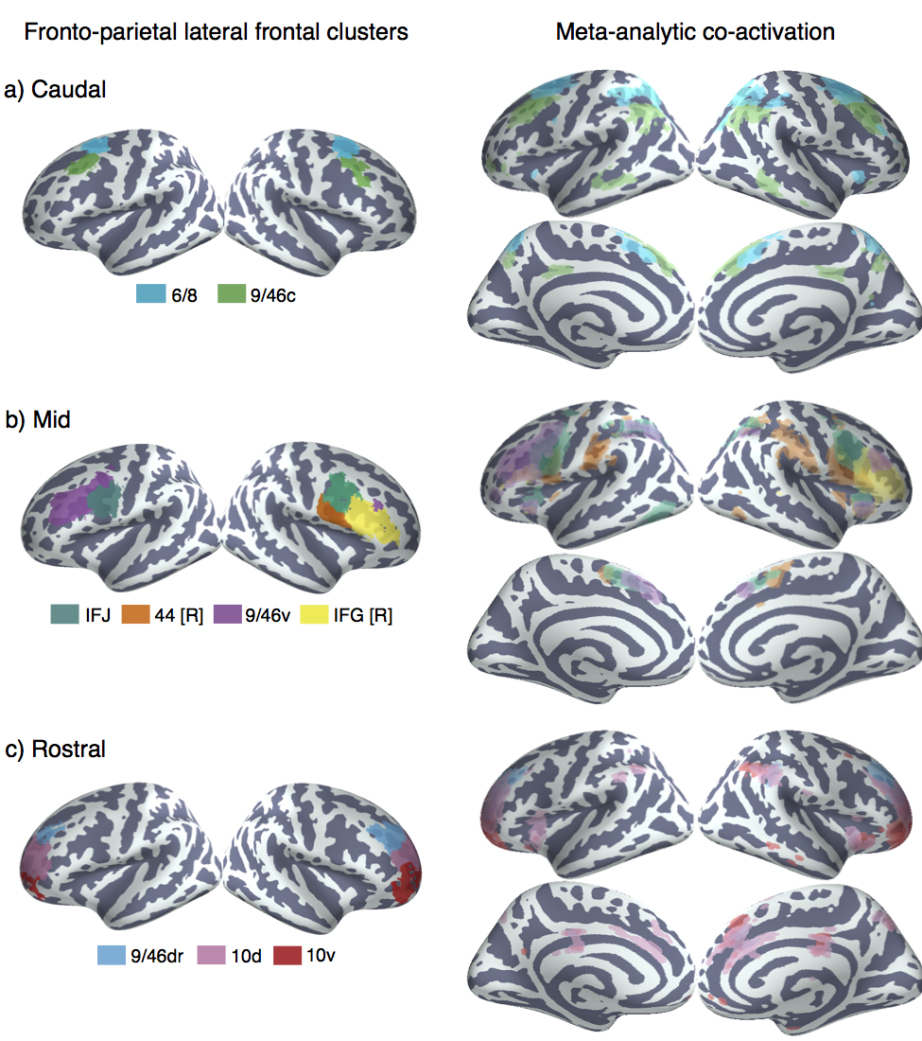  
Figure 3. Anatomical location and meta-analytic contrast of lateral frontal clusters of the fronto-parietal network.** Left) a) Two clusters located in caudal frontal cortex. b) Four clusters located in mid-lateral pre-frontal cortex. c) Three clusters located in rostrolateral pre-frontal clusters. Clusters were assigned labels corresponding to cytoarchitechtonic areas whenever possible. In cases where the region spanned many cytoarchitechtonic areas, broader anatomical (e.g. inferior frontal junction [IFJ]) (inferior frontal junction [IFJ]) labels were assigned. Right) Meta-analytic co-activation contrast of fronto-parietal LFC. Colored voxels indicate significantly greater co-activation with the seed region of the same color than other lateral frontal regions in the fronto-parietal network. Images are presented using neurological convention and are corrected using false discovery rate (q = 0.01).

**Meta-analytic co-activation.** To better understand functional differences between these regions, we directly contrasted the co-activation of each cluster to that of LFC as whole in order to identify voxels across the brain that differentially co-activated with each cluster. Strikingly, we observed that the vast majority of differential co-activation occurred within other cortical association cortex areas such as lateral parietal cortex (LPC), pre-SMA and MCC, and the insula. Across LPC, each LFC cluster co-activated most strongly with distinct areas across a gradient extending from tempo-parietal junction (TPJ) to the lateral parieto-occipital sulcus. For example, clusters ‘9/46c’ and all fronto-polar clusters showed greater co-activation with parietal cortex ventral to the intraparietal sulcus. In contrast, area ‘6/8’ and all four ‘mid’ LPFC clusters showed greater co-activation within and dorsal to the intraparietal sulcus.

Similarly in medial PFC, all clusters except right IFG and ‘9/46dr’ co-activated most strongly with slightly different portions of pre-SMA and MCC. Generally, more anterior clusters co-activated more strongly with more anterior portions of pre-SMA/MCC. For instance, ‘10d’ co-activated most strongly with a anterior mid-cingulate cortex while ‘44 [R]’ co-activated most strongly with the SMA. Finally, in the insula, several LFC sub-regions exhibited differential co-activation with distinct sub-divisions of the insula. For example, cluster ’44 [R]’ co-activated most strongly with the posterior insula (PI)– an important region for pain and sensorimotor processing *23*– whereas IFJ co-activated most strongly with the dorsal anterior insula, a sub-region implicated in goal-directed cognition. In contrast, areas 10d and 10v generally showed greater co-activation with ventral anterior insula, an area implicated in affect *{Chang:2013kx}*.

This observation that the bulk of co-activation differences between LFC sub-regions of the fronto-parietal network occurred within other cortical association areas across the brain is consistent with the hypothesis that association cortex is composed of parallel interdigitated networks *24*. That is, these findings suggest sub-regions of the FPN do not participate with categorically distinct sets of regions across the brain, and instead perform subtly different roles within a parallel distributed network.

**Meta-analytic functional preference.** Next, we used a data-driven approach that surveyed a broad range of fMRI studies to determine which psychological states are differentially associated with each LFC cluster (Figure 1c). For each cluster, we trained a multivariate classifier to predict if studies activated the cluster using a set of 60 psychological topics derived by applying a standard topic modeling approach to the abstracts of articles in the Neurosynth database *26*. From the resulting fitted classifiers, we calculated a measure of how strongly each topic indicated that a study activated each cluster (measured as the log odds-ratio [LOR] of the probability of each topic in studies that activated a given cluster to the probability of the same topic in studies that did not activate the cluster). Values over 0 indicate that the presence of that topic in a study predicts activity in a given region. We report the results of 16 psychological topics that loaded strongly onto LFC regions (Table 1) and restrict interpretation to significant associations using False Discovery Rate (FDR; q < 0.01). In addition, whenever we comparatively discuss sets of regions, we determined significance if the 95% confidence interval (CI) of a given topic did not overlap between two regions. As the latter comparisons are post-hoc and exploratory, caution in interpretation is warranted.

Consistent with a distributed role for the fronto-parietal network in goal-directed cognition, all nine clusters were significantly associated with working-memory, all clusters except 10d and 10v were associated with conflict, and seven clusters were associated with switching (Figure 4). The present results are inconsistent with focal anatomical locations for high-level executive processes and instead suggest these processes likely rely on distributed firing across fronto-parietal network to support goal-directed cognition in the face of interference and conflict *34*.

**Caudal fronto-parietal LFC.** Despite the overall functional similarities between these regions across core aspects of cognitive control, each cluster exhibited distinguishing functional characteristics. Consistent with its co-location with the frontal eye fields, ‘6/8’ was the only cluster significantly associated with saccadic eye movements (i.e ‘gaze’) in the fronto-parietal network, and was also associated with ‘attention’. This pattern suggests that area ‘6/8’ may be important for directing attention to relevant external stimuli to support downstream information processing. However, ‘6/8’ was also significantly associated with ‘ ‘working-memory’, consistent with a recent lesion study implicating the FEF in a causal role in working memory 35. The present results suggest this area is not merely involved in low-level saccadic eye movements, but plays an important role in higher-level cognition.

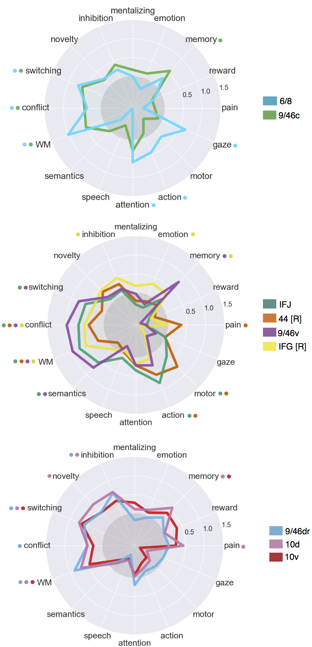

**Figure 4. Meta-analytic functional preference profiles for lateral frontal regions in the fronto-parietal network.**

Each cluster was profiled to determine which psychological concepts best predicted its activation. Each of the three functional groups we identified showed distinct functional profiles, although appreciable variation was observed for each individual cluster. Strength of association is measured in log odds-ratio (LOR), and permutation-based significance corrected using false discovery rate (FDR) of q = 0.01 is indicated next to each psychological concept by color-coded dots corresponding to each region.

In contrast, cluster ‘9/46c’ showed a much less distinctive functional signature, with relatively weak associations to other psychological processes outside of core EF processes and ‘memory’. This relatively diffuse pattern may suggest area ‘9/46c’ may be involved in domain-general processes that span across distinct psychological states in our topic model.

**Mid fronto-parietal LFC.** Clusters ‘9/46v’ and IFJ showed similar functional profiles, exhibiting robust associations with several executive functions (e.g. ‘working memory, ‘conflict’, ‘switching’) in addition to ‘semantics’. Cluster ‘9/46v’ showed a particularly strong association with executive function– exhibiting the strongest relationship across LFC with ‘conflict’; these results are consistent with a hypothesized role for mid-DLPFC as the seat of high-level executive processes,*1*. However, the association between these clusters and ‘semantic’ processing suggests that language and executive function are not mutually exclusive processes, consistent with the hypothesis that language may serve to enable core executive function processes (e.g., maintaining goals in a verbal code).

These results are also consistent with the hypothesis that IFJ is involved in switching *30,36* and is underappreciated in its contributions to cognitive control. However, many other clusters were similarly strongly associated with switching, suggesting IFJ is not likely to be focally responsible for this phenomenon. However, we did find that IFJ was characterized by its significant association with low and high level motor function (i.e. ‘motor’, ‘action’)– an association shared only by 44 [R] in the fronto-parietal network. These results are consistent with the hypothesis that IFJ is important for integrating motor representations with high-level abstract aspects of cognitive control *37*. In contrast, cluster 44 [R]– with its much lower associations with executive functions and a significant association with ‘pain’– may be important for introducing negative affective signals that may require an immediate change in plans into such a process. Although a similar role has been attributed to anterior mid-cingulate cortex *38,39*, present models may overlook area 44’s contributions to this process.

Finally, rIFG showed a relatively distinct functional signature to other mid LPFC clusters, with a much weaker association with conflict, working memory and switching. In contrast, rIFG was significantly associated with ‘inhibition’– consistent with an extensive literature on the role of right inferior frontal gyrus in inhibitory processes *40-42*. rIFG was also robustly associated with ‘emotion’, consistent the hypothesis that this region is crucial for effective emotion regulation and reappraisal *43-45*. However, the relationship between ‘inhibition’ and rIFG was not particularly strong or significantly greater than with other regions, suggesting rIFG may play a more domain general role such as context monitoring (???).

**Rostral fronto-parietal LFC.** The three ‘rostral’ clusters showed relatively similarly functional profiles. Like other clusters in the FPN, ‘rostral’ clusters showed robust– although not particularly strong– associations with various executive processes. However, clusters ‘9/46dr’ and ‘10d’ showed a robust association with ‘inhibition’, while cluster ‘10d’ was significantly associated with ‘novelty’. This pattern was surprisingly similar to that shown by ‘rIFG’, suggesting inhibitory control may not be the sole provenance of that area. However, in contrast to rIFG , these regions were not associated with ‘emotion’, suggesting the inhibition of emotional content may be dependent on rIFG. Moreoever, this pattern is potentially consistent with hierarchical models of control in LPFC, which postulate that more rostral regions represent more abstract goals *46,47*. This is particularly plausible in light of the lack of association between these regions and any low-level processes such as motor function or affect

Finally, the most ventral fronto-polar region, cluster ‘10v’, showed a more distinct pattern, exhibiting weaker associations with all executive processes but a significant association with ‘reward’ (at a lower threshold, q<0.05). This pattern is consistent with its location near orbitofrontal cluster provide support for hypotheses that suggest that the ventral frontal pole may be important for represent the value of stimuli to effectively guide goal-directed behavior *2*.

**Default network**

**Anatomical correspondence.** We identified three distinct default network clusters in LFC, consistent with previous descriptions of the default network and large-scale rs-fMRI parcellations (Figure 5a)*22,24*.The first two clusters were positioned adjacent to each other in ventrolateral prefrontal cortex. The more anterior of the two (‘47/12’) spanned lateral orbitofrontal cortex and IFG orbitalis bilaterally, while a more posterior and dorsal cluster spanned inferior frontal gyrus exclusively in the left hemisphere (‘IFG [L]’). Although ‘IFG [L]’ occupied a greater extent of left IFG than previous descriptions of the default network, the present results are consistent with observations that the default network occupies a greater extent of left IFG in the left hemisphere (YEO ??). Finally, we identified a third cluster in dorsal LPFC consistent with BA9*1*, extending from superior frontal gyrus to dorsal middle frontal gyrus across the superior frontal sulcus. This cluster has long been noted for its lack of anatomical input from lateral and medial parietal cortex (Petrides & Pandya 1984, 1999; Cavada & Goldman-Rakic 1989; Andersen et al. 1990). Thus, despite these cluster’s close proximity to fronto-parietal clusters, we expected them to exhibit very distinct functional profiles.

**Meta-analytic co-activation.** Consistent with the grouping of these clusters with the default network, clusters ‘47/12’ and ‘9’ co-activated much more strongly than the rest of LFC with other default network regions, such as dorsal medial PFC (mPFC), middle temporal gyrus and angular gyrus (Figure 5b). Area ‘9’ showed particularly robust co-activation with key hubs of the default network, such as anterior mPFC and posterior cingulate cortex (PCC), firmly placing this network in the default network despite its proximity to mid-DLPFC. In contrast, ‘IFG [L]’ showed a relatively distinct pattern, showing co-activation with portions of the fronto-parietal network– such as mid-DLPFC and pre-SMA. This pattern is consistent with the fact that left IFG’s contralateral homologue clustered with the fronto-parietal network and suggests this region may not be entirely functionally dissociable from the fronto-parietal network. Moreover, left IFG also showed stronger co-activation with posterior superior temporal sulcus– a key region implicated in semantic processing *{Binder:2009je}* suggesting left IFG may also show a preference towards language topics.

**Figure 5. Lateral frontal regions of the default network** a) Individual clusters projected onto an inflated surface. b) Differences in co-activation between the three regions. Colored voxels activated more frequently in studies in the seed cluster of the same color was also active. c) Functional preference profiles for each cluster, revealing distinct psychological signatures for each sub-region. Strength of association is measured in log odds-ratio (LOR), and permutation-based significance is indicated next to each topic by color-coded dots corresponding to each region.

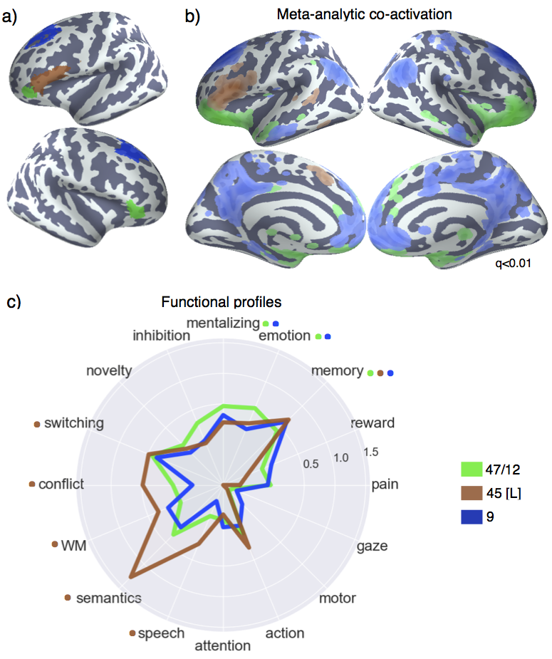

**Meta-analytic functional preference.** In contrast to clusters in the frontal-parietal network, clusters ‘47/12’ and ‘9’ showed no association with any executive processes– particularly notable for cluster ‘9’ due to its spatial proximity to fronto-parietal clusters (Figure 5c). Instead, clusters ‘47/12’ and ‘9’ were significantly associated with a ‘mentalizing’ topic, consistent with the hypothesis that these regions, as part of the dorsal medial subsystem of the default network play a critical role in conceptual processing and mentalizing *49-51*.

Distinct from other default network clusters, left IFG showed a significant association with various executive functions– further highlighting the distributed nature of executive processes across frontal regions. However, left IFG was not associated with inhibition, suggesting inhibition is strongly right lateralized. Furthermore, consistent with this region’s co-location with Broca’s area and co-activation with the superior temporal sulcus, left IFG was significantly associated with ‘semantics’ and ‘speech’. However, in contrast with the long held hypothesis that Broca’s area is important for motor function in language, we did not find any association between left IFG and motor topics. These results are consistent with recent electrophysiological data suggesting Broca’s area is involved in the generation of novel speech motor plans, but not mere motor function *48*. Moreover, left IFG was notable for it’s robust association with ‘semantic’ function– more so than any other region– consistent with the hypothesis that left IFG is a critical higher-level region in the brain’s ‘semantic’ system*11*.

Finally, consistent with the default network’s well-characterized involvement memory*52*, all three LFC default clusters were robustly associated with ‘memory’ and ‘emotion’. This is consistent with a long line of evidence supporting the role of these regions in autobiographical, integrally oriented cognition. Moreover, the left IFG is purported to play a key role in controlled memory retrieval *53,54*– a hypothesis supported by the joint association between executive processes and memory in this region. However, it is also notable that ‘memory’ was associated with many other clusters in the fronto-parietal network, suggesting memory processes are widely distributed across lateral frontal cortex.

**Somatosensory-motor network**

We identified two LFC clusters in this network: dorsal and ventral lateral premotor cortex– PMd and PMv, respectively (Figure 6a). Both clusters were located in dorsal BA 6 *5*, although PMd was slightly more anterior. As a result of its more posterior location, PMv included several voxels in PMC, although the cluster was primarily in pre-motor cortex.

**Figure 6. Meta-analysis of somatosensory clusters.** a) Clusters projected onto an inflated surface b) Differences in co-activation between each cluster and the rest of LFC. Colored voxels activated more frequently in studies in which the seed cluster of the same color was also active. c) Functional preference profiles reveal distinct psychological signatures. Strength of association is measured in log odds-ratio (LOR), and permutation-based significance (q<0.05) is indicated next to each topic by color-coded dots corresponding to each cluster.

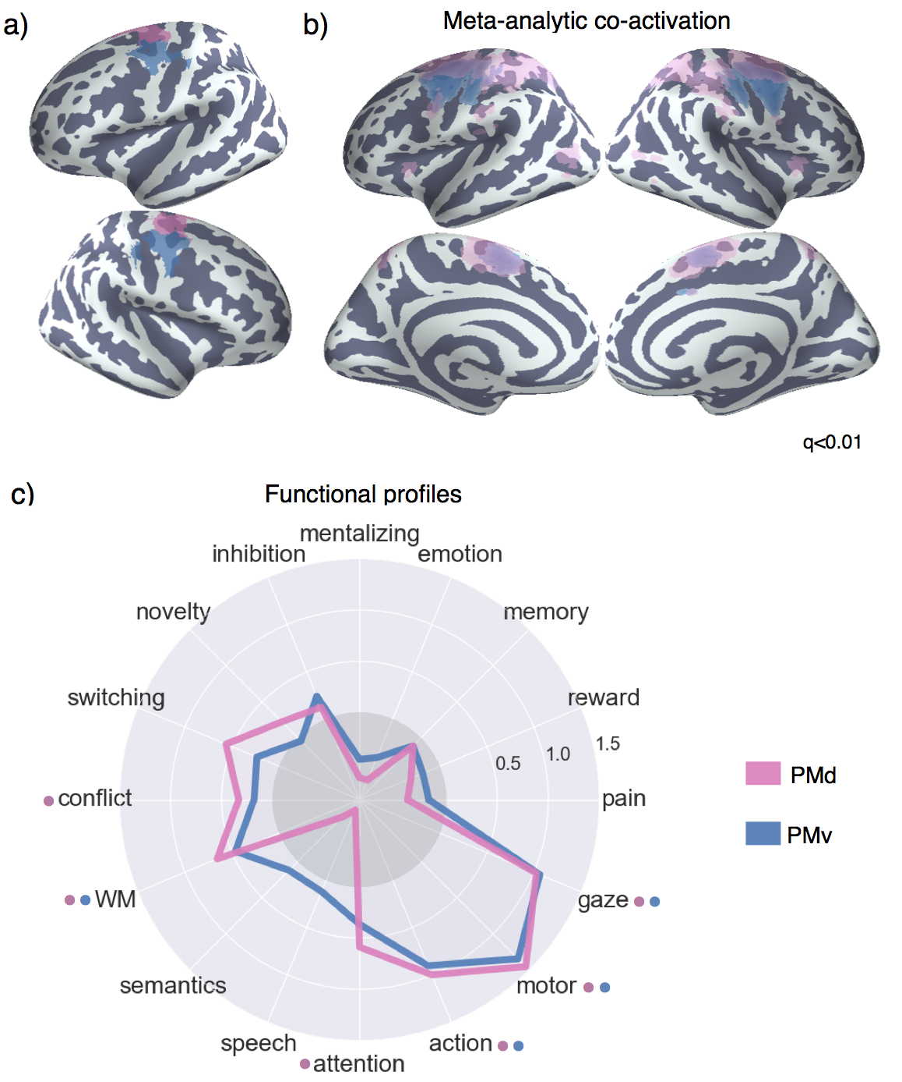

**Meta-analytic co-activation.** Both PMd and PMv showed greater co-activation with nearby voxels in the primary motor and somatosensory cortices, as well as SMA– regions important for the control of movement (Figure 6b). PMd, however, additionally showed greater co-activation with various regions implicated in executive function, such as lateral parietal cortex (LPC) and the anterior insula (AI)– suggesting dorsal pre-motor cortex may engage a broader functional network in support of the cognitive control of motor actions.

**Meta-analytic functional preference.**  The functional preference profiles of both premotor clusters suggests their primary functional role is in core aspects of motor function (Figure 6c). However, both of these the two clusters were also associated with higher-level motor planning (i.e. ‘action’) and working-memory, suggesting these regions are important for higher-level motoric control. Moreover, consistent with PMd’s stronger co-activation with regions previously associated with executive function, PMd was significantly associated with ‘conflict’ and ‘attention’ (although not significantly more so than PMv). Thus, although these two premotor cortex were most strongly associated with motor function, their function is not exclusively limited to low-level processes, and may require the recruitment of higher-level psychological processes for the execution of motor plans.

**Functional distance between clusters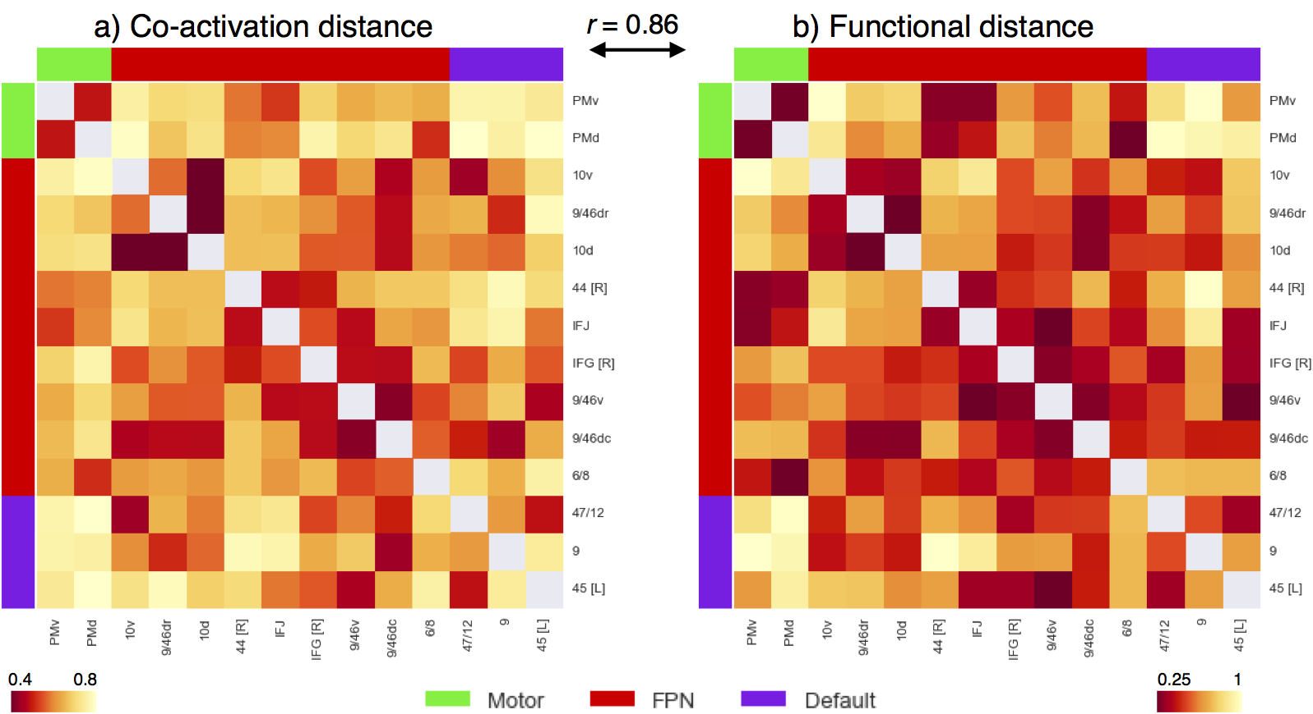Figure 7. Co-activation and functional distance between LFC clusters.** Pearson’s correlation distance between the 14 LFC clusters on the basis of meta-analytic (a) co-activation and (b) functional preference profiles. Although clusters within each network showed generally shorter distances to clusters in the same network than between networks, relatively high functional heterogeneity within each network was observed. The high similarities between these two distance matrices (r = 0.86, p < 0.001), suggests that the differences between regions observed in meta-analytic co-activation are generally accompanied by differences in functional preference profiles. Correlation distances range from 0 to 2, with 2 indicating perfect anti-correlation.

**Functional distance between clusters**

Finally, to examine the overall difference between regions, we computed the correlation distance between clusters on the basis meta-analytic co-activation (Figure 7a) and functional preference profiles (Figure 7b). Supporting the network organization of these clusters, the distance between clusters in the same network was much shorter (co-activation: r=0.58, functional profiles, r=0.5) than the distance between clusters in different networks (co-activation: r=0.7, functional profiles, r=0.7) across both modalities. However, the distance between clusters in the same network was in certain cases relatively high. For example, clusters ‘45 [L]’ and ‘9’ in the default network (r = 0.77) and ’44 [R]’ and ‘10v’ in the fronto-parietal network (r= 0.93) exhibited large functional distances, despite belonging to the same network. Thus, although large-scale networks likely represent a fundamental organizational structure in the brain– and distinct networks tend to support categorically different types psychological processes– our results suggest these networks are relatively heterogeneous. Finally, we also observed that the differences between regions based on meta-analytic co-activation were high similar to those based on functional preference profiles (Pearson’s correlation r = 0.86), suggesting that clusters that show distinct meta-analytic co-activation generally exhibit distinct functional preference profiles.

**Discussion**

In the present study,we applied data-driven methods to the largest meta-analytic database available to systematically map psychological states to discrete lateral frontal cortex anatomy. Importantly, we conducted our analyses broadly both with respect to anatomy– by focusing on the entirety of LFC– and function– by surveying a wide, representative range of psychological states, resulting in a relatively unbiased and comprehensive functional-anatomical mapping. Using co-activation hierarchical clustering, we identified 14 sub-regions in LFC organized into three coarser whole-brain networks (fronto-parietal, default and sensorimotor). We then used multivariate classification to determine which psychological states best-predicted activation in each region, resulting in dissociable psychological profiles for each sub-region. Yet, in contrast with modular models of LFC organization, we observed a complex many-to-many mapping between individual regions and discrete psychological states, suggesting cognitive processes are supported in a distributed fashion by regions organized into whole-brain networks.

Consistent with the emerging view that the brain is composed of complex, distributed networks (XXX), we found that individual regions within the same network exhibited relatively similar psychological profiles to each other. For example, all regions in the fronto-parietal network exhibited strong associations with executive functions, consistent with the hypothesis that the fronto-parietal network critical for flexible externally oriented behavior (XXX). In contrast, regions in different networks showed relatively different psychological profiles from each other– despite occasionally high spatial proximity. For of the default networkshowed no significant association withany s despite being positioned immediately dorsal to area 9/46 of the fronto-parietal network. However, despite being relatively distant, of the default network both

Although networks exhibited relatively robust dissociations, within each network we observed relatively low modularity, in contrast to more localizationist models. For example, sustained activity in DLPFC during working memory tasks has been hypothesized to reflect the active storage of working memory representations in domain-specific buffers*56*. However, we find that working memory recruits activity across a wide range of regions extending from posterior LFC to the lateral frontal pole. Moreover, many of these same regions that are preferentially recruited by working memory are similarly recruited by other executive functions, such as ‘conflict’ and ‘switching’, suggesting sustained activity in these regions supports domain-general processes required to flexibly guide behavior in support of the task goals *57-59*. Tese findings are consistent with a recent alternative view that working memory is supported by the distributed reactivation representations in parietal cortex, rather than isolated and modular maintenance in DLPFC (Postle).

In the same vein, the process of updating task representations when switching task sets has been hypothesized the preferentially recruit specific LFC regions such as the inferior frontal junction *30,36,60,61*. However, we find that ‘switching’ recruits activity across a wide variety of LFC sub-regions as far rostral as the frontal pole. Although these findings do not negate that individual neurons may show functional, the strong dissociation between spatially nearby regions in distinct networks suggest this low functional-anatomical specificity cannot be merely due to the limited spatial fidelity. Instead, these findings are consistent with the view that goal-oriented cognition is supported by highly distributed ‘control’ networks that rely on synchronized whole-brain activity *{Eisenreich:2016jl}62*

Although our results suggest that psychological states are supported by distributed networks, substantial functional heterogeneity within each network suggests individual sub-regions may play dissociable roles. That is, although psychological states are not modularized into individual regions, the multivariate psychological profiles we observed for each region may help formulate dissociable roles for each region within the broader network. For instance, although all fronto-parietal regions were associated with various core executive functions, only IFJ showed additionally robust associations with high and low level motor function. Thus, it is plausible that IFJ may play an important role in biasing motoric representations in support of high-level goals represented in a distributed fashion throughout the network. In contrast, area 9/46v in mid-DLPFC was the region most strongly recruited by core executive processes, but showed no associations with ‘lower-level’ processes such as attention and motor function, suggesting this region is more important for the biasing of abstract representations in more domain-specific regions of posterior cortex *65,66*. Thus, although LFC exhibits relatively low functional modularity, the multivariate psychological profiles in the present study suggest regions differ in nuanced ways to play distinct roles within distributed network to support complex behavior.

Although the present results provide a comprehensive view into the functional organization of LFC, several challenges remain. More broadly, a difficult challenge in cognitive neuroscience is developing the appropriate psychological constructs that distinguish activity in related brain regions. Appropriately modeling the differences between nuanced psychological concepts is particularly difficult for large-scale meta-analyses, as there is no established ontology of psychological constructs, unlike in fields such as genetics *71*. In the present study, we used a data-driven set of topics derived from the abstracts of fMRI papers to represent major psychological phenomena. Although these topics are a major improvement on more simple term based features, due to their data-driven nature they are likely to misrepresent psychological dimensions that are hypothesized to be important for differentiating regions. For example, in our set of 60 topics, only a single topic represented long term memory function, and likely combined memory retrieval and autobiographical memory processes. Although the Neurosynth framework allows researchers to develop custom meta-analyses that can be used to test apriori predictions, the myriad of combinations in which studies can be combined is not conducive to establishing the optimal differentiating dimensions of psychological function between regions.

The classification-based approach we employed is a step in the direction of quantifying the extent to which a given set of psychological features explains variability in brain activity. A promising future direction is to use classification based approaches to find the psychological dimensions that best differentiate patterns in activity between related regions, such as regions within a network. In combination with the adoption of standardized cognitive ontologies, such as the Cognitive Atlas *72,73*, such large-scale approaches should help the development of novel theories of functional brain organization. Moreover, given the limited quality of the summarized coordinate based data in Neurosynth *74* the widespread sharing of richer statistical images in databases such as NeuroVault *75* will greatly improve the fidelity of future meta-analyses.

In the present study, we used relatively unbiased data-driven methods to comprehensively psychological states to individual regions in lateral frontal cortex. These regions were found to belong to large-scale whole-brain networks and generally shared functional properties with other regions in the same network. Moreover, we found that various specific psychological processes that have been previously hypothesized to map onto specific brain regions were widely distributed throughout lateral frontal cortex. However, we identified dissociable functional signature for each sub-region, suggesting that lateral frontal cortex supports a wide variety of psychological state through a mixture of network-level dynamics and moderate degree of functional specialization.

**Methods**

**Dataset.** We analyzed version 0.6 of the Neurosynth database *17*, a repository of 11,406 fMRI studies and over 410,000 activation peaks that span the full range of the published neuroimaging literature. Each observation contains the peak activations for all contrasts reported in a study’s table as well as the frequency of all of the words in the article abstract. A heuristic but relatively accurate approach is used to detect and convert reported coordinates to the standard MNI space (see: Yarkoni et al., 2011). As such, all activations and subsequent analyses are in MNI152 coordinate space. The scikit-learn Python package *76* was used for all machine learning analyses. Analyses were performed using the core Neurosynth python tools (https://github.com/neurosynth/neurosynth).

**Lateral frontal cortex mask.** To select clusters from whole-brain clustering solutions in lateral frontal cortex, we defined an LFC anatomical mask. Crucially, we only used this mask to select clusters that fell within this mask, and not to exclude individual voxels. First, we included voxels with a greater than 30% chance of falling in the frontal lobes according to the Montreal Neurological Institute structural probabilistic atlas *77,78* and excluded medial voxels within 14mm of the midline. To focus on lateral frontal cortex, we excluded voxels that were exclusively located on the orbital surface– ensuring to include lateral orbitofrontal voxels– by removing voxels in the superior and medial orbital gyri according to the AAL atlas and voxels with a greater than 30% probability of falling in ‘Frontal Operculum Cortex’ in the Harvard-Oxford atlas. Finally, we also excluded far ventral voxels of OFC (Z < -14mm) that were not excluded using anatomical atlases.

### Co-activation clustering. Next, we clustered individual grey-matter cortical voxels across the whole brain based on their meta-analytic co-activation with the whole brain across studies in the database (Figure 1A). In order to avoid potentially biased or arbitrary cluster boundaries, we clustered the whole cortex and selected clusters for further analysis that fell within an anatomically defined LFC mask. Critically, we did not mask out voxels that were slightly outside of our mask– we either included or excluded entire clusters. This was particularly important for clusters near the edge of our LFC mask– as functional boundaries may not conform to anatomical boundaries– and at coarse clustering solutions– given the well-established finding that at least 4-5 whole-brain networks include voxels in lateral frontal cortex 22,24. For whole-cortex clustering, we excluded voxels with less than 30% probability of falling in grey matter according to the Harvard-Oxford anatomical atlas and those with very low activation in the database (less than 100 studies per voxel). In general, Neurosynth’s activation mask (derived from the standard MNI152 template distributed with FSL) corresponded highly with probabilistic locations of cerebral cortex, with the exception of portions of dorsal precentral gyrus– which showed low activation although it was more than 50% likely to be in cerebral cortex.

We calculated the co-activation between each cortical voxel and every other voxel in the brain (including sub-cortex) by correlating the target voxel’s activation pattern across studies with the rest of the brain. Activation in each voxel is represented as a binary vector of length 11,406 (the number of studies). A value of 1 indicated that the voxel fell within 10 mm of an activation focus reported in a particular study, and a value of 0 indicated that it did not. Because correlating the activation of every cortical voxel with every other voxel in the brain would result in a very large matrix (112,358 cortical voxels x 171,534 whole-brain voxels) that would be very computationally costly to cluster so as to identify distinct LFC regions. Hence, we reduced the dimensionality of the whole brain to 100 components using principal components analysis (PCA; the precise choice of number of components does not materially affect the reported results). Next, we computed the Pearson correlation distance between every voxel in the MFC mask with each whole-brain PCA component, resulting in a matrix that described the frequency with which each cortical voxel co-activated with the rest of the brain.

As an additional pre-processing step, we standardized each cortical voxel’s co-activation with other brain voxels to ensure clustering would be driven by relative differences in whole brain co-activation and not the overall activation rate of each voxel. That is, if two voxels co-activated with similar voxels across the brain, we should consider them to be relatively similar even if one of those voxels activates more frequently (and thus has slightly stronger correlations with all voxels). This adjustment was particularly important as preliminary analyses indicated that regions with very high rates of activation (e.g. pre-SMA/mid-cingulate cortex) more readily clustered into multiple clusters with few voxels, reflecting base rates in activation, although differences in their functional associations were minimal. Indeed, preliminary analyses confirmed that standardizing the co-activation matrix alleviated this concern. At k = 70, the mean activation rate of each cluster showed no correlation with voxel size when Z-scoring was used (r=0.05), as compared to when the raw co-activation matrix was used (r = -0.65) at k = 70. Additionally, the range of cluster sizes was compressed, resulting in more evenly sized clusters. Cluster sizes ranged from 352 to 4546 voxels using the raw activation, compared to a range of 560 to 2862 voxels using standardized co-activation. See Chapter 4 for a more in depth investigation of the implications of this preprocessing strategy.

We applied hierarchical clustering with Ward’s linkage to the normalized co-activation matrix, resulting in a whole-brain linkage matrix. Ward’s clustering was selected as this algorithm is recommended as the best compromise between accuracy (e.g., fit to data) and reproducibility for clustering fMRI data *79*. However, this clustering algorithm is seldom used for whole-brain clustering because the computational time increases cubically [Θ(N³)] as a function of samples. We employed the fastcluster algorithm *80*—a package of libraries that enable efficient hierarchical clustering [Θ(N2)]—to achieve whole-brain clustering.

Since the optimality of a given clustering depends in large part on investigators’ goals, the preferred level of analysis, and the nature and dimensionality of the available data, identifying the ‘correct’ number of clusters is arguably an intractable problem *72,81,82*. However, in order to attempt to objectively guide the choice of choice of number of clusters to further analyze, we selected viable solutions using the silhouette score– a measure of within-cluster cohesion. Crucially, as we were specifically interested in the fit of the clustering to lateral frontal cortex, we only calculated the silhouette score with respect to voxels within our lateral frontal cortex mask. The silhouette coefficient was defined as (b – a) / max(a, b), where a is the mean intra-cluster distance and b is the distance between a sample and the nearest cluster of which the sample is not a part. Solutions that minimized the average distance between voxels within each cluster received a greater score. Once having selected three k solution sizes to focus on (k = 5, 33 and 70 whole-brain clusters), we extracted only those clusters from these solutions that had a substantial percentage of voxels in our LFC mask. We varied the percentage of voxels within our LFC mask required to include a region across granularities with the objective maximizing coverage in LFC without including extraneous clusters with little presence in LFC. We arrived at 10% of voxels in a cluster within LFC at k=5, 25% of voxels at k=33 and 50% of voxels at k=70.

To understand the anatomical correspondence of the resulting clusters, we consulted a variety of anatomical and cytoarchitechtonic atlases. To locate each cluster anatomically, we used the probabilistic Harvard-Oxford atlas (H-O) that is packaged with FSL. We also visually compared the location of our clusters to the Petrides’ (2005) and Jülich micro-anatomical atlases included in FSL *5,78*. Regions were assigned names in accordance to Brodmann areas (BA) whenever clusters were sufficient small to correspond to a single area (e.g. ‘area 9/46v’). Clusters were given functional names when they spanned multiple cytoarchitechtonic areas (e.g. IFJ) or multiple clusters spanned a single cytoarchitechtonic area (e.g. PMd & PMv). Note that although names were assigned to ease the discussion of these regions, we do not make strong claims of correspondence between functionally and anatomically defined regions, as we observed several discrepancies throughout LFC.

### Co-activation profiles. Next, we analyzed the differences in whole brain co-activation between the resulting clusters (Figure 1B) in order to understand the patterns of co-activation that differentiates these clusters. To highlight differences between clusters, we contrasted the co-activation of each cluster to the mean co-activation of the entire LFC. To do so, we performed a meta-analytic contrast between studies that activated a given cluster, and studies that activated a LFC mask composed of all clusters. The resulting images identify voxels with a greater probability of co-activating with the cluster of interest than with LFC on average. For example, voxels in blue in Figure 5b indicate voxels that are active more frequently in studies in which ‘area 9’ is active than in studies in which other LFC on average is active. We calculated p-values for each voxel using a two-way chi-square test between the two sets of studies and thresholded the co-activation images using the False Discovery Rate (q<0.01). The resulting images were binarized for display purposes and visualized using the NiLearn library for Python.

### Topic modeling. Although term-based meta-analysis maps in Neurosynth closely resemble the results of manual meta-analyses of the same concepts, there is a high degree of redundancy between terms (e.g. ‘episodes’ and ‘episodic’), as well as potential ambiguity as to the meaning of an individual word out of context (e.g. ‘memory’ can indicate working memory or episodic memory). To remedy this problem, we employed a reduced semantic representation of the latent conceptual structure underlying the neuroimaging literature: a set of 60 topics derived using latent dirichlet allocation (LDA) topic-modeling 83. This procedure was identical to that used in a previous study 84, except for the use of a smaller number of topics and a much larger version of the Neurosynth database. The generative topic model derives 60 independent topics from the co-occurrence of all words in the abstracts of fMRI studies in the database. Each topic loads onto individual words to a varying extent, facilitating the interpretation of topics; for example, a working memory topic loads highest on the words “memory, WM, load”, while an episodic memory topic loads on “memory, retrieval, events:”. Note that both topics highly load on the word “memory”, but the meaning of this word is disambiguated because it is contextualized by other words that strongly load onto that topic. Although the set of topics included 25 topics representing non-psychological phenomena– such as the nature of the subject population (e.g. gender, special populations) and methods (e.g., words such as “images”, “voxels”)—these topics were not explicitly excluded as they were rarely the strongest loading topics for any region. For all of our results, we focus on a set of 16 topics that strongly loaded onto lateral frontal cortex clusters (Table 3.1). These topics were obtained by determining the two strongest loading topics for each region.

|  |  |  |
| --- | --- | --- |
| Topic name | Top words |  |
| action | action actions motor goal mirror planning imitation execution | |
| attention | attention attentional visual spatial search location orienting target | |
| conflict | conflict interference incongruent stroop congruent selection competition color | |
| emotion | emotional emotion regulation affective pictures emotions arousal affect | |
| gaze | eye gaze eyes movements saccades target saccade visual | |
| inhibition | inhibition inhibitory stop motor sustained nogo transient suppression | |
| memory | memory retrieval encoding recognition episodic items recall words | |
| mentalizing | social empathy moral person judgments mentalizing mental mind | |
| motor | motor movement movements sensorimotor finger somatosensory sensory force | |
| novelty | target targets novelty oddball distractor distractors deception mismatch | |
| pain | pain stimulation somatosensory painful intensity sensory chronic noxious | |
| reward | reward sleep anticipation monetary rewards motivation incentive loss | |
| semantics | semantic words word lexical verbs abstract meaning verb | |
| speech | speech auditory sounds sound perception voice acoustic listening | |
| switching | switching rule executive switch rules flexibility shifting aggression | |
| WM | memory working wm load verbal maintenance delay encoding | |

**Table 1. Topics most strongly associated with lateral frontal regions.** Eight strongest loading words for each topic are listed, in descending order of association strength.

### Meta-analytic functional preference profiles. We generated functional preference profiles by determining which psychological topics best predicted each cluster’s activity across fMRI studies (Figure 1C). First, we selected two sets of studies: studies that activated a given cluster– defined as activating at least 5% of voxels in the cluster– and studies that did not– defined as activating no voxels in the cluster. For each cluster, we trained a naive Bayes classifier to discriminate these two sets of studies based the loading of psychological topics onto individual studies. We chose naive Bayes because (i) we have previously had success applying this algorithm to Neurosynth data 17; (ii) these algorithms perform well on many types of data 85, (iii) they require almost no tuning of parameters to achieve a high level of performance; and (iv) they produce highly interpretable solutions, in contrast to many other machine learning approaches (e.g., support vector machines or decision tree forests).

We trained models to predict whether or not fMRI studies activated each cluster, given the semantic content of the studies. In other words, if we know which psychological topics are mentioned in a study how well can we predict whether the study activates a specific region? We used 4-fold cross-validation for testing and calculated the mean score across all folds as the final measure of performance. We scored our models using the area under the curve of the receiver operating characteristic (AUC-ROC)– a summary metric of classification performance that takes into account both sensitivity and specificity. AUC-ROC was chosen because this measure is not detrimentally affected by unbalanced data *86*, which was important because each region varied in the ratio of studies that activated it to the studies that did not.

To generate functional preference profiles, we extracted from the naive Bayes models the log odds-ratio (LOR) of a topic being present in active studies versus inactive studies. The LOR was defined, for each region, as the log of the ratio between the probability of a given topic in active studies and the probability of the topic in inactive studies, for each region. LOR values above 0 indicate that a psychological topic is predictive of activation of a given region. To determine the statistical significance of these associations, we permuted the class labels and extracted the LOR for each topic 1000 times. This resulted in a null distribution of LOR for each topic and each cluster. Using this null distribution, we calculated p-values for each pairwise relationship between psychological concepts and regions, and reported associations significant after controlling for multiple comparisons using False Discovery Rate with q<0.01. Finally, to determine if certain topics showed greater preference for one cluster versus another, we conducted exploratory, post-hoc comparisons by determining if the 95% confidence intervals (CI) of the LOR of a specific topic for a one region overlapped wit h the 95% CI of the same topic in another region. We generated CIs using bootstrapping, sampling with replacement and recalculating log-odds ratios for each region 1000 times. A full reference figure of the loading between topic and regions, including CIs, is available in Appendix I. The ordering of the labels around the polar plot was determined using hierarchical clustering with average linkage, resulting in an order that concisely conveyed the functional differences between LFC’s sub-regions.

References

1. Petrides, M. Lateral prefrontal cortex: architectonic and functional organization. Philosophical Transactions of the Royal Society of London B: Biological Sciences **360,** 781–795 (2005).

2. Orr, J. M., Smolker, H. R. & Banich, M. T. Organization of the Human Frontal Pole Revealed by Large-Scale DTI-Based Connectivity: Implications for Control of Behavior. PLoS ONE **10,** e0124797 (2015).

3. Neubert, F.-X., Mars, R. B., Thomas, A. G., Sallet, J. & Rushworth, M. F. S. Comparison of Human Ventral Frontal Cortex Areas for Cognitive Control and Language with Areas in Monkey Frontal Cortex. Neuron **81,** 700–713 (2014).

4. Sallet, J. et al. The Organization of Dorsal Frontal Cortex in Humans and Macaques. Journal of Neuroscience **33,** 12255–12274 (2013).

5. Eickhoff, S. B. et al. Assignment of functional activations to probabilistic cytoarchitectonic areas revisited. NeuroImage **36,** 511–521 (2007).

6. Amunts, K. & Zilles, K. Architectonic Mapping of the Human Brain beyond Brodmann. Neuron **88,** 1086–1107 (2015).

7. Mattar, M. G., Cole, M. W., Thompson-Schill, S. L. & Bassett, D. S. A Functional Cartography of Cognitive Systems. PLoS Comput Biol **11,** e1004533 (2015).

8. Nee, D. E. et al. A Meta-analysis of Executive Components of Working Memory. Cerebral Cortex **23,** 264–282 (2013).

9. Wager, T. D. & Smith, E. E. Neuroimaging studies of working memory: a meta-analysis. Cogn Affect Behav Neurosci **3,** 255–274 (2003).

10. Derrfuss, J., Brass, M., Neumann, J. & Cramon, von, D. Y. Involvement of the inferior frontal junction in cognitive control: Meta-analyses of switching and Stroop studies. Hum. Brain Mapp. **25,** 22–34 (2005).

11. Binder, J. R., Desai, R. H., Graves, W. W. & Conant, L. L. Where is the semantic system? A critical review and meta-analysis of 120 functional neuroimaging studies. Cereb. Cortex **19,** 2767–2796 (2009).

12. Turkeltaub, P. E., Eden, G. F., Jones, K. M. & Zeffiro, T. A. Meta-analysis of the functional neuroanatomy of single-word reading: method and validation. NeuroImage **16,** 765–780 (2002).

13. Gilbert, S. J. et al. Functional specialization within rostral prefrontal cortex (area 10): a meta-analysis. Journal of Cognitive Neuroscience **18,** 932–948 (2006).

14. Northoff, G. et al. Self-referential processing in our brain--a meta-analysis of imaging studies on the self. NeuroImage **31,** 440–457 (2006).

15. Poldrack, R. A. Can cognitive processes be inferred from neuroimaging data? Trends in Cognitive Sciences **10,** 59–63 (2006).

16. Nelson, S. M. et al. Role of the anterior insula in task-level control and focal attention. Brain Structure and Function **214,** 669–680 (2010).

17. Yarkoni, T., Poldrack, R. A., Nichols, T. E., Van Essen, D. C. & Wager, T. D. Large-scale automated synthesis of human functional neuroimaging data. Nat Meth **8,** 665–670 (2011).

18. Toro, R., Fox, P. T. & Paus, T. Functional Coactivation Map of the Human Brain. Cerebral Cortex **18,** 2553–2559 (2008).

19. Robinson, J. L., Laird, A. R., Glahn, D. C., Lovallo, W. R. & Fox, P. T. Metaanalytic connectivity modeling: Delineating the functional connectivity of the human amygdala. Hum. Brain Mapp. **31,** 173–184 (2010).

20. Smith, S. M. et al. Correspondence of the brain's functional architecture during activation and rest. PNAS **106,** 13040–13045 (2009).

21. Petersen, S. E. & Sporns, O. Brain Networks and Cognitive Architectures. Neuron **88,** 207–219 (2015).

22. Power, J. D. et al. Functional Network Organization of the Human Brain. Neuron **72,** 665–678 (2011).

23. Chang, L. J., Yarkoni, T., Khaw, M. W. & Sanfey, A. G. Decoding the Role of the Insula in Human Cognition: Functional Parcellation and Large-Scale Reverse Inference. Cerebral Cortex **23,** 739–749 (2013).

24. Yeo, B. T. T. et al. The organization of the human cerebral cortex estimated by intrinsic functional connectivity. Journal of Neurophysiology **106,** 1125–1165 (2011).

25. Andrews-Hanna, J. R. The Brain's Default Network and Its Adaptive Role in Internal Mentation. The Neuroscientist **18,** 251–270 (2012).

26. Poldrack, R. A. et al. Discovering Relations Between Mind, Brain, and Mental Disorders Using Topic Mapping. PLoS Comput Biol **8,** e1002707 (2012).

27. Wager, T. D. et al. An fMRI-Based Neurologic Signature of Physical Pain. N Engl J Med **368,** 1388–1397 (2013).

28. Rolls, E. T. et al. Representations of Pleasant and Painful Touch in the Human Orbitofrontal and Cingulate Cortices. Cerebral Cortex **13,** 308–317 (2003).

29. Paus, T. Location and function of the human frontal eye-field: A selective review. Neuropsychologia **34,** 475–483 (1996).

30. Brass, M., Derrfuss, J., Forstmann, B. & Cramon, von, D. Y. The role of the inferior frontal junction area in cognitive control. Trends in Cognitive Sciences **9,** 314–316 (2005).

31. Muhle-Karbe, P. S. et al. Co-Activation-Based Parcellation of the Lateral Prefrontal Cortex Delineates the Inferior Frontal Junction Area. Cerebral Cortex 1–17 (2015). doi:10.1093/cercor/bhv073

32. Bludau, S. et al. Cytoarchitecture, probability maps and functions of the human frontal pole. NeuroImage **93,** 260–275 (2014).

33. Burgess, P. W., Dumontheil, I. & Gilbert, S. J. The gateway hypothesis of rostral prefrontal cortex (area 10) function. Trends in Cognitive Sciences **11,** 290–298 (2007).

34. Nee, D. E. & Brown, J. W. Rostral–caudal gradients of abstraction revealed by multi-variate pattern analysis of working memory. NeuroImage **63,** 1285–1294 (2012).

35. Mackey, W. E., Devinsky, O., Doyle, W. K., Meager, M. R. & Curtis, C. E. Human Dorsolateral Prefrontal Cortex Is Not Necessary for Spatial Working Memory. J. Neurosci. **36,** 2847–2856 (2016).

36. Derrfuss, J., Brass, M., Neumann, J. & Cramon, von, D. Y. Involvement of the inferior frontal junction in cognitive control: Meta-analyses of switching and Stroop studies. Hum. Brain Mapp. **25,** 22–34 (2005).

37. De Baene, W., Albers, A. M. & Brass, M. The what and how components of cognitive control. NeuroImage **63,** 203–211 (2012).

38. Shackman, A. J. et al. The integration of negative affect, pain and cognitive control in the cingulate cortex. Nat Rev Neurosci **12,** 154–167 (2011).

39. Cavanagh, J. F. & Shackman, A. J. Frontal midline theta reflects anxiety and cognitive control: Meta-analytic evidence. Journal of Physiology-Paris **109,** 3–15 (2015).

40. Aron, A. R., Robbins, T. W. & Poldrack, R. A. Inhibition and the right inferior frontal cortex. Trends in Cognitive Sciences **8,** 170–177 (2004).

41. Munakata, Y. et al. A unified framework for inhibitory control. Trends in Cognitive Sciences **15,** 453–459 (2011).

42. Depue, B. E., Orr, J. M., Smolker, H. R., Naaz, F. & Banich, M. T. The Organization of Right Prefrontal Networks Reveals Common Mechanisms of Inhibitory Regulation Across Cognitive, Emotional, and Motor Processes. Cereb. Cortex **26,** 1634–1646 (2016).

43. Frank, D. W., Dewitt, M. & Hudgens-Haney, M. Emotion regulation: quantitative meta-analysis of functional activation and deactivation. Neuroscience & … (2014). doi:10.1016/j.neubiorev.2014.06.010

44. Opialla, S. et al. Neural circuits of emotion regulation: a comparison of mindfulness-based and cognitive reappraisal strategies. Eur Arch Psychiatry Clin Neurosci **265,** 45–55 (2015).

45. Wager, T. D., Davidson, M. L., Hughes, B. L., Lindquist, M. A. & Ochsner, K. N. Prefrontal-Subcortical Pathways Mediating Successful Emotion Regulation. Neuron **59,** 1037–1050 (2008).

46. Botvinick, M. M. Hierarchical models of behavior and prefrontal function. Trends in Cognitive Sciences **12,** 201–208 (2008).

47. Badre, D. & D'Esposito, M. Is the rostro-caudal axis of the frontal lobe hierarchical? Nat Rev Neurosci **10,** 659–669 (2009).

48. Flinker, A. et al. Redefining the role of Broca's area in speech. PNAS **112,** 2871–2875 (2015).

49. Andrews Hanna, J. R., Smallwood, J. & Spreng, R. N. The default network and self-generated thought: component processes, dynamic control, and clinical relevance. Ann. N.Y. Acad. Sci. **1316,** 29–52 (2014).

50. Spreng, R. N., Sepulcre, J., Turner, G. R., Stevens, W. D. & Schacter, D. L. Intrinsic architecture underlying the relations among the default, dorsal attention, and frontoparietal control networks of the human brain. Journal of Cognitive Neuroscience **25,** 74–86 (2013).

51. Spreng, R. N. & Grady, C. L. Patterns of brain activity supporting autobiographical memory, prospection, and theory of mind, and their relationship to the default mode network. Journal of Cognitive Neuroscience **22,** 1112–1123 (2010).

52. Andrews Hanna, J. R., Saxe, R. & Yarkoni, T. Contributions of episodic retrieval and mentalizing to autobiographical thought: Evidence from functional neuroimaging, resting-state connectivity, and fMRI meta-analyses. NeuroImage **91,** 324–335 (2014).

53. Badre, D. & Wagner, A. D. Left ventrolateral prefrontal cortex and the cognitive control of memory. Neuropsychologia **45,** 2883–2901 (2007).

54. Snyder, H. R., Banich, M. T. & Munakata, Y. Choosing Our Words: Retrieval and Selection Processes Recruit Shared Neural Substrates in Left Ventrolateral Prefrontal Cortex. http://dx.doi.org/10.1162/jocn_a_00023 **23,** 3470–3482 (2011).

55. Friston, K. Beyond phrenology: what can neuroimaging tell us about distributed circuitry? Annu. Rev. Neurosci. **25,** 221–250 (2002).

56. Baddeley, A. Working memory: looking back and looking forward. Nat Rev Neurosci **4,** 829–839 (2003).

57. Curtis, C. E. & Lee, D. Beyond working memory: the role of persistent activity in decision making. Trends in Cognitive Sciences **14,** 216–222 (2010).

58. Riggall, A. C. & Postle, B. R. The relationship between working memory storage and elevated activity as measured with functional magnetic resonance imaging. J. Neurosci. **32,** 12990–12998 (2012).

59. Postle, B. R. in (ed. Watanabe, M.) Prefrontal Cortex as an Executive, Emotional and Social Brain, 1–14 (Springer, 2016).

60. Derrfuss, J., Brass, M., Cramon, von, D. Y., Lohmann, G. & Amunts, K. Neural activations at the junction of the inferior frontal sulcus and the inferior precentral sulcus: Interindividual variability, reliability, and association with sulcal morphology. Hum. Brain Mapp. **30,** 299–311 (2009).

61. Muhle-Karbe, P. S. et al. Co-Activation-Based Parcellation of the Lateral Prefrontal Cortex Delineates the Inferior Frontal Junction Area. Cerebral Cortex bhv073–17 (2015). doi:10.1093/cercor/bhv073

62. Power, J. D. & Petersen, S. E. Control-related systems in the human brain. Current Opinion in Neurobiology **23,** 223–228 (2013).

63. Botvinick, M., Nystrom, L. E., Fissell, K., Carter, C. S. & Cohen, J. D. Conflict monitoring versus selection-for-action in anterior cingulate cortex. Nature **402,** 179–181 (1999).

64. Carter, C. S. et al. Anterior cingulate cortex, error detection, and the online monitoring of performance. Science **280,** 747–749 (1998).

65. Banich, M. T. Executive Function The Search for an Integrated Account. Current Directions in Psychological Science **18,** 89–94 (2009).

66. Badre, D. Cognitive control, hierarchy, and the rostro-caudal organization of the frontal lobes. Trends in Cognitive Sciences **12,** 193–200 (2008).

67. Chatham, C. H. et al. Cognitive Control Reflects Context Monitoring, Not Motoric Stopping, in Response Inhibition. PLoS ONE **7,** e31546 (2012).

68. Sharp, D. J. et al. Distinct frontal systems for response inhibition, attentional capture, and error processing. Proceedings of the National Academy of Sciences **107,** 6106–6111 (2010).

69. Buckner, R. L., Andrews Hanna, J. R. & Schacter, D. L. The Brain's Default Network. Ann. N.Y. Acad. Sci. **1124,** 1–38 (2008).

70. Binder, J. R. & Desai, R. H. The neurobiology of semantic memory. Trends in Cognitive Sciences **15,** 527–536 (2011).

71. Botstein, D., Cherry, J. M., Ashburner, M. & Ball, C. A. Gene Ontology: tool for the unification of biology. Nat Genet (2000).

72. Poldrack, R. A. & Yarkoni, T. From Brain Maps to Cognitive Ontologies: Informatics and the Search for Mental Structure. Annual Review of Psychology **67,** 587–612 (2016).

73. Poldrack, R. A. et al. The cognitive atlas: toward a knowledge foundation for cognitive neuroscience. Front Neuroinform **5,** 17 (2011).

74. Salimi-Khorshidi, G., Smith, S. M., Keltner, J. R., Wager, T. D. & Nichols, T. E. Meta-analysis of neuroimaging data: A comparison of image-based and coordinate-based pooling of studies. NeuroImage **45,** 810–823 (2009).

75. Gorgolewski, K. J. et al. NeuroVault.org: a web-based repository for collecting and sharing unthresholded statistical maps of the human brain. Front Neuroinform **9,** 8 (2015).

76. Pedregosa, F. et al. Scikit-learn: Machine Learning in Python. Journal of Machine Learning Research **12,** 2825–2830 (2011).

77. Collins, D. L., Holmes, C. J., Peters, T. M. & Evans, A. C. Automatic 3‐D model‐based neuroanatomical segmentation. Hum. Brain Mapp. **3,** 190–208 (1995).

78. Mazziotta, J. et al. A probabilistic atlas and reference system for the human brain: International Consortium for Brain Mapping (ICBM). Philosophical Transactions of the Royal Society of London B: Biological Sciences **356,** 1293–1322 (2001).

79. Thirion, B., Varoquaux, G., Dohmatob, E. & Poline, J.-B. Which fMRI clustering gives good brain parcellations? Front Neurosci **8,** 167 (2014).

80. Müllner, D. fastcluster: Fast Hierarchical, Agglomerative Clustering Routines for Rand Python. J. Stat. Soft. **53,** (2013).

81. Varoquaux, G. & Thirion, B. How machine learning is shaping cognitive neuroimaging. Gigascience **3,** 28 (2014).

82. Eickhoff, S. B., Thirion, B., Varoquaux, G. & Bzdok, D. Connectivity-based parcellation: Critique and implications. Hum. Brain Mapp. **36,** 4771–4792 (2015).

83. Blei, D. M., Ng, A. Y. & Jordan, M. I. Latent dirichlet allocation. The Journal of Machine Learning Research **3,** 993–1022 (2003).

84. Poldrack, R. A. et al. Discovering relations between mind, brain, and mental disorders using topic mapping. PLoS Comput Biol **8,** e1002707 (2012).

85. Androutsopoulos, I., Koutsias, J. & Chandrinos, K. V. An evaluation of naive bayesian anti-spam filtering. Proceedings of the workshop on Machine Learning in the New Information Age 9–17 (2000).

86. Jeni, L. A., Cohn, J. F. & la Torre, De, F. Facing Imbalanced Data Recommendations for the Use of Performance Metrics. Int Conf Affect Comput Intell Interact Workshops **2013,** 245–251 (2013).